
COMET BAY COLLEGE

Physics - Unit 2 - Task 2
Waves Test
Name: SOLUTIONS Total Marks /46
Note: Show working for all mathematical answers.
Question 1:
Waves can be either mechanical waves or non-mechanical waves.
- Give two difference between them. [2 marks]
Speed – electromagnetic waves always at 3 x 10⁸ m s⁻¹, mechanical waves vary (1 mark)
Mechanical waves need a medium, electromagnetic waves do not (1 mark)

- Electromagnetic waves are said to be both wave-like and particle-like. That is, electromagnetic radiation exhibits a “dual nature”. With examples, explain what is meant by a “dual nature”?
[2 marks]
Wave-like in that they show wave behaviours such reflection, refraction and diffraction. (1 mark)
Particle-like is shown by spectra and the photoelectric effect. (1 mark)

Question 2:
Label the parts of the wave (four parts to label) and name the type of wave. [2 marks]
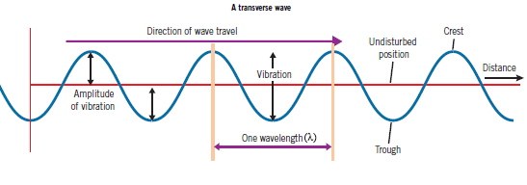
Minus ½ mark for every incorrect
A ______________________ Wave

Energy direction
__________
__________
_________________
__________
Question 3:
A guitar string plucked so that it produces it fundamental frequency of 216 Hz. If the speed of sound on that day was 346 m s⁻¹, what was the length of the string? [3 marks]
f = 216 Hz
v = 346 m s⁻¹
λ = $\frac{v}{f}= \frac{346}{216}$
λ = 1.60185 m (1 mark)
= ½ λ = 0.5 × 1.60185 (1 mark)
= 0.801 m (1 mark)

Question 4:
Two violins strings of the same note are played, but a loud – soft sound is heard. What is the name given to this phenomena and why does it occur? [2 marks]
Beat. (1 mark)

The two strings are slightly out of tune (have slightly different frequencies). These two waves interfere with each other producing beats. (1 mark)

Question 5:
Complete the following wave diagrams then underneath the diagram write the name of the wave behaviour that is occurring. [6 marks]
Waves passing through an opening  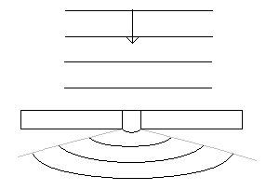 | Person above aquarium listening to noisy fish.  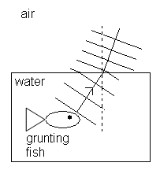 | Waves reflected on a circular wall.  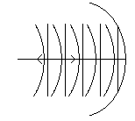

Waves passing through an opening  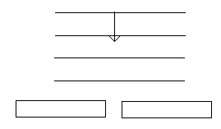  Diffraction | Person above aquarium listening to noisy fish.  air  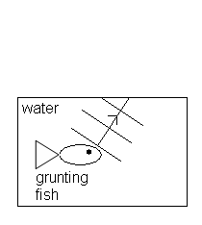  Refraction | Waves reflected on a circular wall.  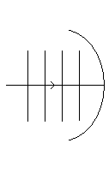  Reflection
Question 6:
Two loudspeakers are set up outside and both emit a single frequency sound in phase. A person walking along a line parallel to the loudspeakers notices that the intensity of sound varies between loud and quiet.
Loudspeaker
Loudspeaker
Person walks along this line
Use physics principles to explain why there are loud regions and quiet regions in this situation.
[4 marks]
In some locations the sound waves from each speaker are arriving in phase.
This leads to constructive interference and sound is heard as pressure fluctuates.

In some locations the sound waves from each speaker are arriving out of phase by half a wavelength.
This leads to destructive interference and no sound is heard as pressure is constant.

Question 7:
- Determine the amplitude and wavelength in the following wave. [2 marks]

5.00 x 10⁻³ m
2.50 x 10⁻¹ m

Wavelength: _______________
0.00 1.50 3.00 4.50 6.00 7.50 9.00
Amplitude: ________________

- If the wave in the graph is travelling at 4.00 m s⁻¹, what is the period of the wave? [3 marks]
v = λf
f = $\frac{v}{}= \frac{4}{0.005}$ = 800 Hz (1 mark)

T = $\frac{1}{f}= \frac{1}{800}=$0.00125 s (1 mark)
T = 1.25 x 10⁻³ s (1 mark)

Question 8:
A sound wave travels through water to meet a boundary with a solid concrete wall of a dam.
Sound wave
Water
Solid Concrete Wall

- Draw a possible path of the sound wave as it refracts into the concrete. Indicate whether the angle of incidence is greater or less than the angle of refraction on the diagram. [1 mark]
Indicates refraction angle greater than incidence angle. (1 mark)

- The wave fronts in the water are shown on the diagram. Indicate the general pattern of wave fronts when the sound wave travels in the solid concrete wall. [1 mark]
Refraction waves greater in concrete (1 mark) indicates faster in concrete.
- Is it possible for total internal reflection to occur at this boundary? Explain briefly. [1 mark]
Yes this can occur if second medium has higher wave speed. (1 mark)

Question 9:
When a source of waves, whether light, sound or any other, is moving towards an observer, the wavelength detected by the observer will appear to be different to the actual wavelength emitted by the source. This is because each wave is emitted a little closer to the observer than the previous one and is not so far behind the previous wave as it would be if the source was stationary. The reverse is the case if the source is moving away from the observer.

In the particular case of sound waves, a stationary observer hears a change in the pitch of a sound that is being emitted by a moving source. For instance if a speeding ambulance emitted a high pitched sound, then as it approached the observer he would hear a variation in pitch. As the ambulance passed and sped away the observer would also hear a change in pitch.

The diagram below shows a source of sound moving to the right with a speed of u. The outer circle represents a sound wave front, which was emitted when the source was at position A. The period of this wave front is T, the velocity is v and wavelength is λ.
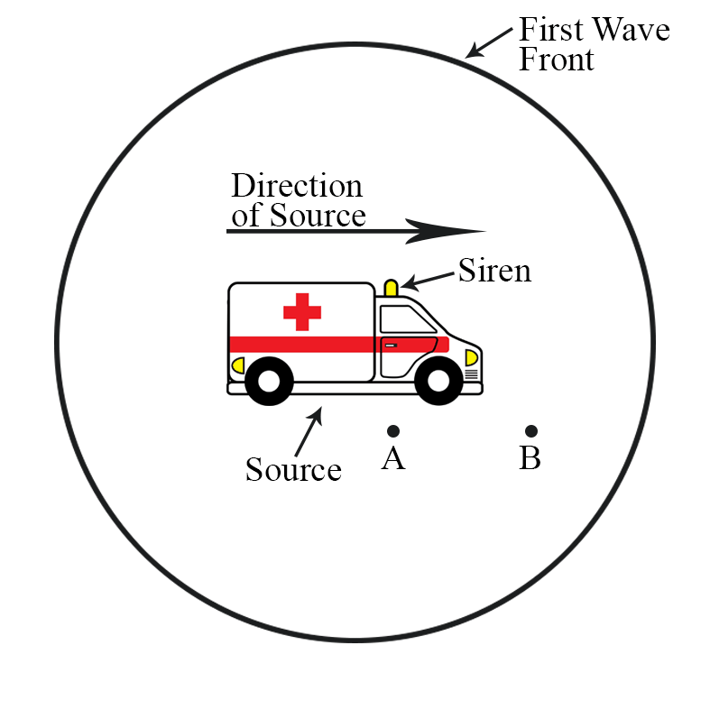
When the source has moved to position B, a second wave front is emitted. This now means that the distance between the wave fronts in the forward direction and those in the reverse direction are different. These distances are the wavelengths as perceived by observers to the front and rear, respectively.
- Upon what property of sound waves does pitch
depend? [1 mark]
Pitch of a note depends upon the frequency. (1 mark)

- In the diagrams below, the ambulance’s siren is emitting a constant frequency. Complete the diagrams by drawing wave fronts to the front and rear of the ambulance. Note that in diagram A, the ambulance is stationary and in diagram B it is travelling to the right at high speed. [4 marks]
- Does the actual pitch of a sound emitted by the ambulance, change as it approaches and passes an observer? Explain your answer. [2 marks]
The actual pitch of the siren remains constant. (1 mark)
The higher and lower pitch heard by the observer is a function of the source moving, not the actual source itself. (1 mark)

Question 10:
Andrew is blowing air over the end of a pipe. When he blows softly across the end, a microphone connected to a C.R.O. shows a frequency of 256 Hz. When he blows over the pipe much harder, a frequency of 1024 Hz is shown on the screen. The speed of sound on the day is 332 m s⁻¹.
- Is the pipe open at both ends or open at one end and closed at the other? [1 marks]
open at both ends (1 mark)

- Fully explain the answer you gave. [3 marks]
Ratio of frequencies $\frac{1024}{256}$ = 4 (1 mark)
Therefore in 4th harmonic when blown across harder.
Only open ended pipes have even harmonics as an antinode is needed on an open end. (1 mark)
Closed pipes have a node at one end and an antinode at the other end so can’t have even harmonic. (1 mark)

- What is the length of the pipe assuming the 256 Hz is the fundamental frequency? [2 marks]
f = 256 Hz f = $\frac{nv}{2L}$
v = 332 m s⁻¹ 256 = $\frac{1 ×332}{2 L}$
length of pipe = ½ λ L = 0.649 m

λ = $\frac{v}{f}= \frac{332}{256}$
λ = 1.297 m
l = ½ λ
= ½ × 1.297
l = 0.649 m

Question 11:
Matt starts by running his finger around the top of a wine glass. He then increases the speed until it sounds a note. Explain why the glass sounds the note and what is the name given to this phenomena.
[4 marks]
Phenomena is resonance. (1 mark)
Wine glass forced to vibrate by finger running around top. (1 mark)
When sound is heard, frequency of forced vibrations matches natural frequency of glass. (1 mark)
At resonance, vibrations of glass greatly increased and a sound is produced. (1 mark)

